QFit-Universal-Workout-Tracker

Ali developed and captured UI screenshots by testing and validating the live dashboard pages.

1. Home Page
http://localhost:8080/QFit-Universal-Workout-Tracker/
Or
http://localhost:8080/QFit-Universal-Workout-Tracker/index.jsp
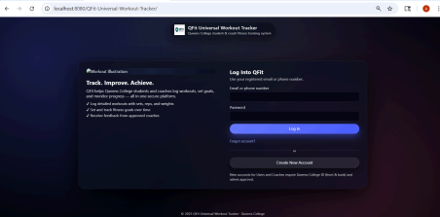
2. Create New Account / register page
http://localhost:8080/QFit-Universal-Workout-Tracker/register.jsp
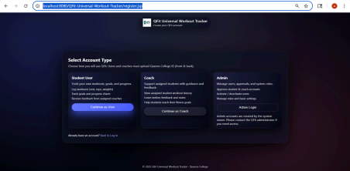
3. Users / students register form page
http://localhost:8080/QFit-Universal-Workout-Tracker/registerUser.jsp
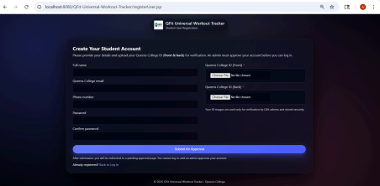
4. Coach register form page
http://localhost:8080/QFit-Universal-Workout-Tracker/register.jsp
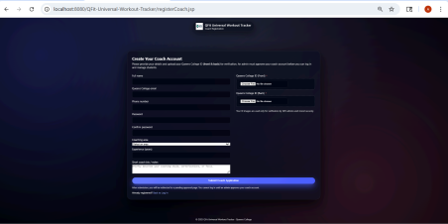
5. After User / Coach submit form that they can see this page
http://localhost:8080/QFit-Universal-Workout-Tracker/pendingApproval.jsp
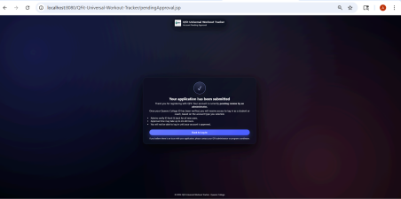
6. Admin Dashboard page
http://localhost:8080/QFit-Universal-Workout-Tracker/admin/adminDashboard.jsp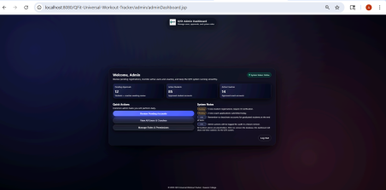
7. Admin - User Management
http://localhost:8080/QFit-Universal-Workout-Tracker/admin/adminUserManagement. jsp
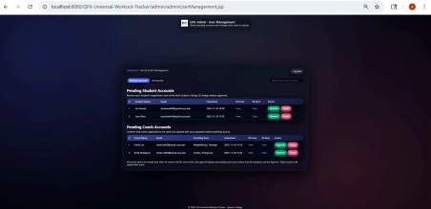
8. Admin - Pending Accounts
http://localhost:8080/QFit-Universal-Workout-Tracker/admin/adminPending.jsp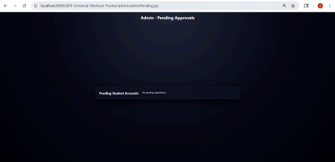
9. Admin All Accounts
http://localhost:8080/QFit-Universal-Workout-Tracker/admin/adminAllAccounts.jsp 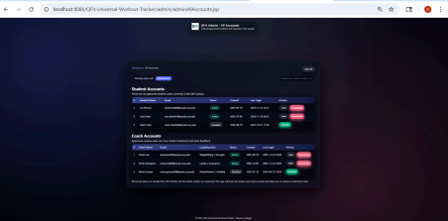
10. Admin - Roles Page
http://localhost:8080/QFit-Universal-Workout-Tracker/admin/adminRoles.jsp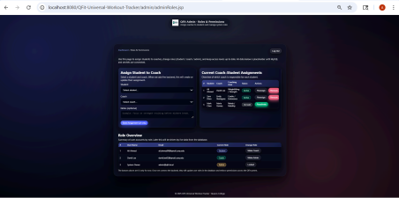
Note: if anyone want to download in there computer
Here is few Steps:
Try this:
cd ~/Desktop
Clone the project
git clone https://github.com/thasneemsha/QC-Remote-Gym-Tracker.git Enter the project folder
cd QC-Remote-Gym-Tracker
Switch to Ali’s branch
git checkout feature/ali-tester-docs
Build the project (Maven)
mvn clean package
Deploy to Tomcat (simple)
Copy or drag the WAR file into Tomcat’s webapps folder:
copy target\QFit-Universal-Workout-Tracker.war C:\path\to\tomcat\webapps\
Start Tomcat
C:\path\to\tomcat\bin\startup.bat

